# Produktion2030, call 16:

# Circularity in Manufacturing industry,

# Step 1, Feasibility study

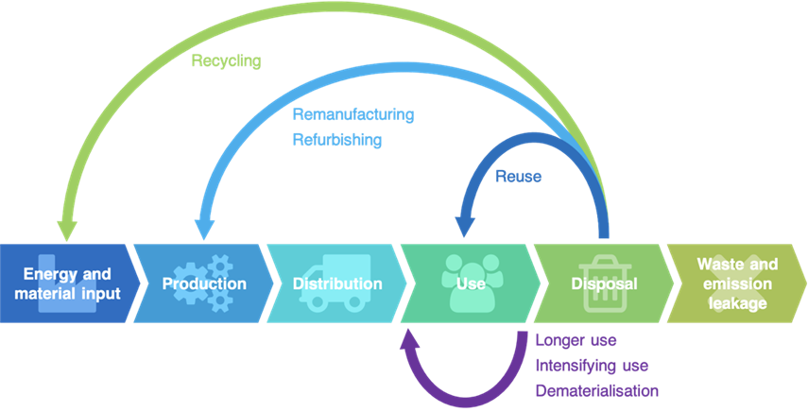

# Template for:

# Project summary, Step 1, feasibility study (max 2 pages)

# Project proposal, Step 1, feasibility study (max 5 pages)

# Template:

# Project Summary (max 2 pages), Call 16, Step 1, feasibility study

*The information you provide in these two pages will be published, please make sure that your information that can be freely published and distributed.*

# Project[1]: <Title> <Acronym>

## Project partners:

|  |  |  |  |  |
| --- | --- | --- | --- | --- |
|  | **Participant organisation** | **Main contact** | **Female/ Male** | **Time in project  (% of full time)** |
| 1 | nn | Project coordinator: mm | M/F | X % |
| 2 | nn | mm |  |  |
| 3 | nn | mm |  |  |
| 4 |  |  |  |  |
| 5 |  |  |  |  |
| 6 |  |  |  |  |

**Project coordinator: < first name last name > < partner name >**

**Project duration: Start <2022-XX-XX> – END <202X-XX-XX>**

**Funding applied for: < X SEK> (max 800 000 SEK)**

**Produktion2030 Challenge area(s) addressed:**

**Project summary** (max 4500 characters)

(Font and size: Times New Roman, 12 p)

< End of project summary, max 2 pages >

***When submitting your full proposal, you are required to send your 2-page project summary to Produktion2030:*** [***Cecilia.warrol@produktion2030.se***](mailto:Cecilia.warrol@produktion2030.se)

# Template:

# Project proposal (max 5 pages), Call 16, Step 1, feasibility study

Please remove all instructions in red before submitting

This template should be followed for proposals to of Produktion2030 16th call, Step 1-Feasibility studies. The call has the theme “Circularity in Manufacturing industry”,

The proposal size is limited to a maximum of 5 pages size standing A4. Applicants should use the font Times New Roman, 12p, black text. The information you provide in these two pages will be published, please make sure that your information that can be freely published and distributed.

# Project[2]: <Title> <Acronym>

## Project partners:

|  |  |  |  |  |
| --- | --- | --- | --- | --- |
|  | **Participant organisation** | **Main contact** | **Female/ Male** | **Time in project  (% of full time)** |
| 1 | nn | Project coordinator: mm | M/F | X % |
| 2 | nn | mm |  |  |
| 3 | nn | mm |  |  |
| 4 |  |  |  |  |
| 5 |  |  |  |  |
| 6 |  |  |  |  |

**Project coordinator: < first name last name > < partner name >**

**Project duration: Start <2022-XX-XX> – END <202X-XX-XX>**

**Funding applied for: < X SEK> (max 800 000 SEK)**

**Produktion2030 Challenge area(s) addressed:**

# Potential

## Impact goals

*Describe how the project will contribute to the specific impact goals of the call*

* **Impact goals of call 16 (step 1 and 2):**
* Produktion2030's expectations of the projects' effects after Step 2 are:
* increased service life of products and production systems
* reduced resource waste along entire product life cycles and value chains
* increased use of renewable raw materials

## State of the art

*Clearly describe the state of the art within your project’s scope,   
this may be further elaborated on in Step 2.*

## Research level and novelty

*Describe the project’s research excellence and originality*

## Industrial and societal impact

*Describe the potential of the project’s results in industry and in society.   
Please describe the potential and expected impact of Step 2 as well as Step 1.*

# Actors

## Project consortium

*Describe how the competence, project management, specific roles and resource requirements of the consortium match the goals of the project*

## Gender equality between actors

*Describe how the project consortium is composed regarding gender distribution  
and balance of power and influence between men and women*

# Feasibility

## Gender equality in implementation

*Describe how gender aspects are defined and integrated into the feasibility study*

## Plan for implementation

*Describe how the proposed plan for Step 1, feasibility study, will be implemented.*

# Project plan

*Please provide a GANTT chart for work packages, including responsible person*



*Please provide partner involvement, expressed in person-months*



Comments on resource planning:

# Budget

*The maximum funding contribution for the whole projects in step 1, is 80%*

|  |  |  |
| --- | --- | --- |
| **Costs (SEK)** | **Total for the project** | **From Vinnova** |
| Personnel |  |  |
| Equipment |  |  |
| Other direct costs, including travels |  |  |
| Consultants, licenses |  |  |
| Indirect costs (overhead) |  |  |
| **Total costs** |  |  |

Comments on the budget:

< The project proposal, including, tables, charts, references etc. should not be longer than 5 pages. Content beyond the 5 pages is disregarded during the evaluation.>

1. *Proposal assessments will be made by international experts, therefore English is recommended.   
   Further content details may be found at* [*http://www.produktion2030.se*](http://www.produktion2030.se) *This project summary will be publicly published and distributed*
2. *Proposal assessments will be made by international experts, therefore English is recommended.   
   Further content details may be found at* [*http://www.produktion2030.se*](http://www.produktion2030.se) *This project summary will be publicly published and distributed*